Parents’ Guide for Booking Appointments
Browse to https://hulltrinityhouse.parentseveningsystem.co.uk/

Parents’ Evenings will take place in the Sports Hall
Car parking is available at George Street Multi-storey – charges are applicable

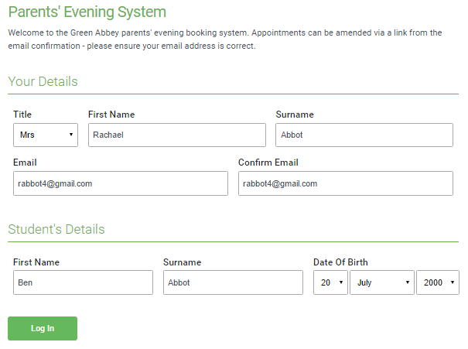 | Step 1: Login  Please fill out the details on the page then click the Log In button.  A confirmation of your appointments will be sent to the email address you provide.  Please use your child’s ‘preferred’ forename that matches our records (no abbreviations) and your child’s date of birth (eg 21/03/2000)
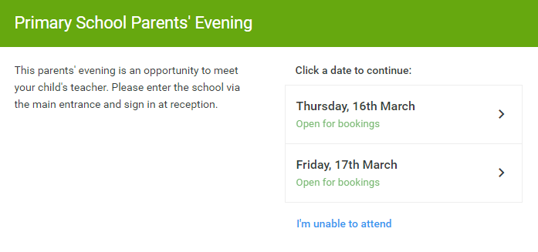 | Step 2: Select Parents’ Evening  Click on the date you wish to book.  Unable to make all of the dates listed? Click I'm unable to attend.
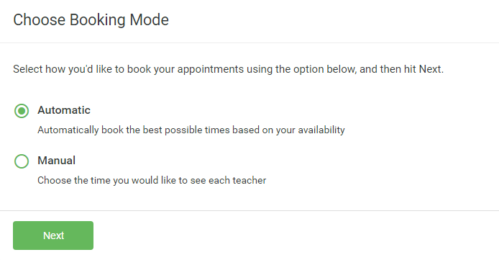 | Step 3: Select Booking Mode  Choose Automatic if you'd like the system to suggest the shortest possible appointment schedule based on the times you're available to attend. Or if you'd rather choose the times to book with each teacher, choose Manual. Then press Next.  We recommend choosing the automatic booking mode when browsing on a mobile phone.
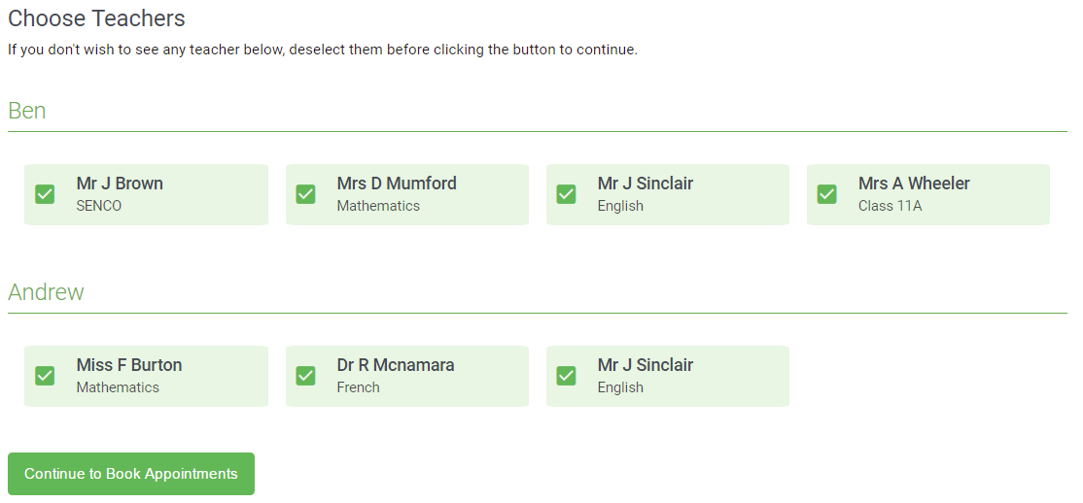 | Step 4: Choose Teachers  Your children’s teachers will appear.  If you chose the automatic booking mode, drag the sliders at the top of the screen to indicate the earliest and latest you can attend.  If you chose to manually select teachers, Ensure the teachers you wish to see are selected in green. If you do not wish to see a teacher, click on their name to de-select them.  Click on the Continue button to proceed.
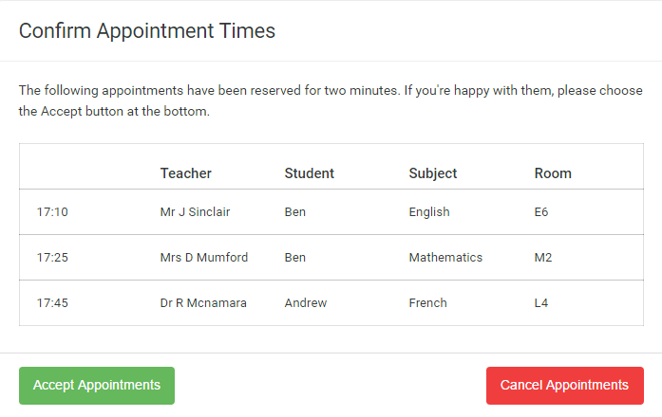 | Step 5a (Automatic): Book Appointments  If you chose the automatic booking mode, you should see provisional appointments which are held for 2 minutes. To keep them, choose Accept at the bottom left.  If it wasn’t possible to book every selected teacher during the times you are able to attend, you can either adjust the teachers you wish to meet with and try again, or switch to manual booking mode (Step 5b).
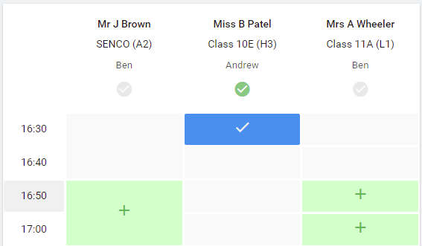  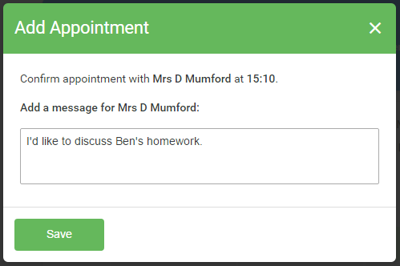 | Step 5b (Manual): Book Appointments  Click any of the green cells to make an appointment. Blue cells signify where you already have an appointment. Grey cells are unavailable.  To change an appointment, delete the original by hovering over the blue box and clicking Delete. Then choose an alternate time.  After clicking on a green cell to make an appointment, a pop-up box appears where you can optionally leave a message for the teacher to say what you’d like to discuss or raise anything beforehand.  Once you’re finished booking all appointments, at the top of the page in the alert box, press click here to finish the booking process.
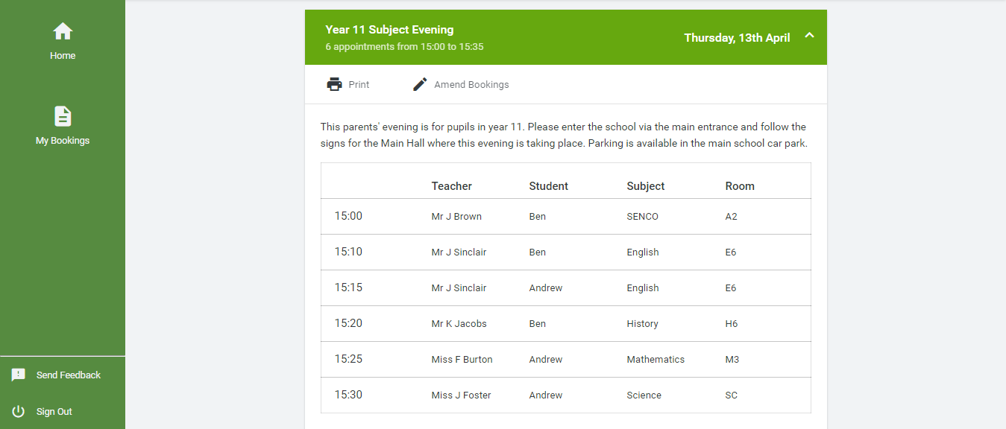 | Step 6: Finished  You’re now on the My Bookings page and all your bookings are below. An email confirmation has been sent  Printing Appointments  You can also view and print your appointments online by clicking the “Appointments” tab. Please bring a print out of your appointment time to the Parents Evening  Viewing/Editing Appointments  You can change your appointments by clicking on “Add/Edit/Delete Appointments”

